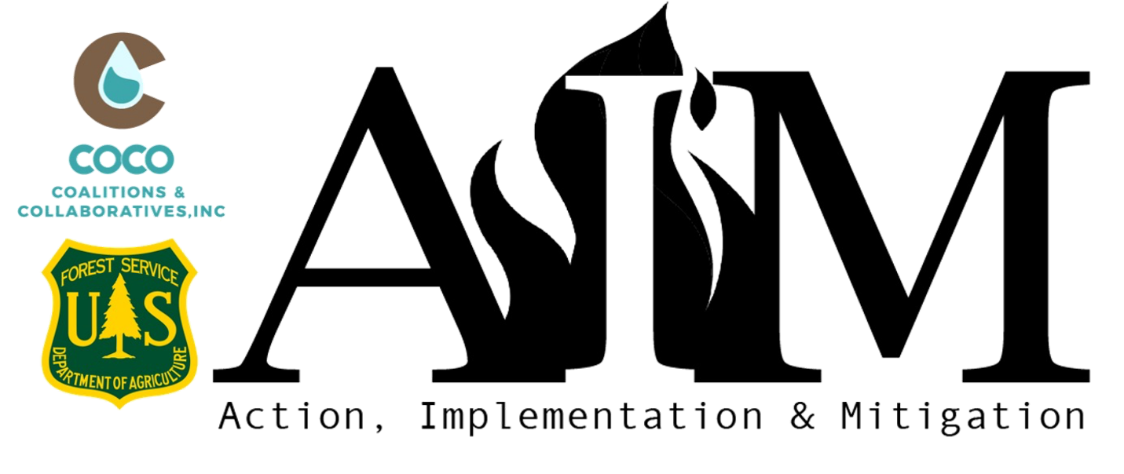
Project Name
Organization Name
Organization Phone Number
Project Manager Name
Project Manager Title
Project Manager Phone Number
Physical Address Street |  | City
State | Select State | ZIP

Website URL
Fiscal Agent (If Applicable)

- Organization Type
Select an Organization Type

- Description of your Organization (1000 characters or less)
When did your organization come into being? How long has your organization been engaged in wildfire mitigation activities? Is the organization’s primary focus wildfire risk reduction or does it host additional programs? What is your current staff capacity (number of personnel and whether they are full time, part time, or volunteers)? How much of the staff is currently engaged in wildfire mitigation activities and what percentage of staff time is dedicated to those activities? Does the organization have administrative help for processing reimbursement requests and reporting?
Organization Narrative

- Wildfire Risk Reduction Activities (1250 characters or less)
Please describe your organization's specific wildfire mitigation accomplishments in the last two years.

Risk Reduction Narrative

- Please explain the community’s fire risk, specifically as it pertains to your AIM proposal.

Explain your community fire risk here

- Add Risk Map (PNG, JPG or PDF)
If you have issues uploading your map here please email map with your completed application form.

- Does the community have a Community Wildfire Protection Plan (CWPP) or Community Wildfire Risk Assessment?

Choose an answer

- Provide a link to the CWPP or Community Wildfire Risk Assessment listed above. Please do not send us a copy of the document unless requested.

CWPP Link

- Is your proposed project one of the recommended actions in your CWPP, Community Wildfire Risk Assessment or FEMA Natural Hazard Mitigation Plan?

Choose an answer

- If you do not have a completed CWPP or Community Wildfire Risk Assessment, or the project is not included as a recommendation, please explain why your project is a priority. (500 characters or less).

Explain

Project Information

- Project Focus Area (check all that apply)
☐ | Personnel Capacity
☐ | Fuels Reduction
☐ | Planning
☐ | Equipment

- Stage of Development
Choose an answer

- Jurisdiction or Ownership
Choose an answer

- Is the proposed project located near or adjacent to public lands? (Please explain in the Project Area Description question)
Choose an answer

- Project Summary and Objectives
Provide a brief summary of your proposed project (1-2 sentences) and list 1-3 project objectives.

Enter Project Summary here

- Project Location Overview (2500 characters or less)
Please provide an overview of the project location. Identify vegetation types, fuel types or hazard rating and the relative wildfire risk to the communities, ecosystems, and other community values. Explain the community in which your project will take place (including population and number of structures), the project’s land ownership breakdown, and why this project is considered a priority.

Overview of Project Location

Project Description
When filling out the project description, please refer to the prompts below. Please list specific activity, action steps and deliverables. Add additional activities if necessary. If not applicable, please list N/A.

For example:
This community has one main access road and it is overgrown. Currently a wildfire could impact the safe evacuation of the town and limit the firefighter’s ability to fight the wildfire. For the project we will be creating a shaded fuel break for 25 ft on each side of the 5 mile long road, and expect XX acres will be treated. Contractors will use a mix of treatment methods including a masticator and hand crews. Larger wood will be left as firewood for residents to pick up and slash will be hauled to the landfill. We will work with adjacent landowners for permission to extend the fuel break up to 50 feet onto private land.
Activity 1: Create a fuel break along main ingress/egress to town
Action Steps:
- Coordinate with county for easement access
- Coordinate with homeowners
- Hire contractor
- Complete work
- Establish plan for future upkeep
Deliverables:
- 5 miles of road mitigated
- Ability for firefighters to access area in the event of a wildfire and a safe evacuation route for homeowners

- Scope of Work for Personnel
Discuss the number of hours under this position, how those hours will be spent, how that position will increase capacity for accomplishing on-the-ground mitigation work in the near future, and whether the organization is leveraging other funding for the position.

Narrative
Activity 1:
Action Steps:
Deliverables:

Scope of Work for Fuels Reduction Projects:
Specify activities within the project description. Include how many treatments will be applied to the area and what kind of treatment will be used (i.e. removing vegetation, mastication, hand treatment, burning slash, piling slash, chipping, etc.), number of structures gaining defensible space, and the acreage. Explain how this project aligns with active, proposed or past projects on nearby lands, public or private. AIM funds must be used within one year of the contracted award date. If project proposal includes prescribed burning and the burn cannot be completed in the one-year time frame, please provide a contingency plan for use of funds.

Narrative
Activity 1:
Action Steps:
Deliverables:

Scope of Work for Planning Efforts:
Describe the area to be covered by the CWPP or Community Assessment and the roles of key players (time, meeting support, facilitation, technical expertise or other contributions). What percentage of planning will be completed in-house? If work is contracted out, why?
If you are updating a CWPP, please describe what has changed within your community since the last update (i.e. building codes, landscape changes, development, etc.). What was accomplished under the previous plan and how much of the plan was implemented? With the existing plan, if mitigation actions were not implemented or there were barriers in implementing the plan, how will this plan overcome those challenges?

Narrative
Activity 1:
Action Steps:
Deliverables:

Scope of Work for Equipment:
Please describe how you plan to use the equipment, how often the equipment will be in use (i.e. hours/days per week), and identify staff qualified or will be trained to operate the equipment (given that you are not requesting equipment used on a volunteer basis). Detail how equipment will increase capacity.

Narrative
Activity 1:
Action Steps:
Deliverables:

- Treatment Map
If applicable, please attach a treatment map specific to the project location. Include as much detail as possible. PLEASE INCLUDE LEGEND.
If you have issues uploading your map here please email map with your completed application form.

- Project Timeline
Outline the proposed timeline for each activity/component of the project, including major milestones and the anticipated outcomes that will define project completion. If you are working through a multi-year project, clearly define the portion which AIM funding will support.

Example Activity Timeline:
- May –mobilize contractors and equipment
- June –work begins, goal 2 miles/approx. 18 acres
- July – work goal 2 miles/approx. 18 acres
- August – work could slow due to fire conditions, goal 1 mile/approx. 9 acres
- September – work could slow due to fire conditions, goal 1 mile/approx. 9 acres
- October – work goal 14.2 acres
- November - shaded fuel break completed
- Winter - write and share project success stories

Explain project timeline here

Budget

- Download Budget template and complete
Completely fill out budget and submit with completed application.
https://co-co.org/wp-content/uploads/2022/05/AIM-Grant-Budget_TEMPLATE.xlsx

- Budget Narrative (2500 characters or less)
Please make sure all items described in the budget narrative have been fully explained in previous sections. Address each line item in the budget and explain how funds will be allocated.
Describe source(s) of matching funds and whether cash or in-kind match has been confirmed. Remember, if your proposal involves chipping or mitigation work that benefits residents, you must include at least a 50% cash match from the resident (increased resident match is appreciated). If you need a lower homeowner match, please justify. Describe the role of each entity involved in project implementation, any known terms of contracts associated with the project, and your ability to leverage AIM funds with other funding sources. Consider attaching bids or contract estimates from industry if available.
Because AIM funding is from a federal source you may not use federal funds as a match. Additional leveraged federal resources add value, and should be added to your budget, but are not necessary to receive this funding.

Explain your budget here

- Strategic Value of Project (1500 characters or less)
How will this project increase mitigation activities, or create broader collaborative landscape risk reduction efforts in a strategic way over time? Based on the category(s) for which you are seeking AIM funding, explain how your project contributes to the greater wildfire management strategy in your community.

For Personnel Proposals: Please the strategic value of the new capacity, and how you anticipate this capacity will lead to increased mitigation action on the ground.

For Fuels Mitigation Projects: Please explain whether the project will be implemented across land ownership boundaries; if it is within a priority area identified in a completed Community Wildfire Protection Plan, Wildfire Risk Assessment or FEMA Mitigation Plan; if it is part of a larger landscape‐scale treatment effort; if it addresses a specific environmental consideration, and/or if it is in geographic proximity to public lands that have recently been treated or are in the queue for treatment.

For Planning Projects: Please describe the need for the planning and how it will support your overall program. Discuss involvement of partners, if any, and what they will bring to the table and how the planning will lead to increase mitigation outcomes.
For example: If you are requesting contracting services for the drafting of a CWPP please describe how using a contractor over a staff member will increase your organization’s capacity.

For Equipment: Please discuss how the equipment will help you to be more effective or efficient in your mitigation efforts, lead to an increase in acres treated, engagement of new or existing partners, and how you will maintain the equipment beyond the 12-month grant period.

Strategic Value narrative here

- Why do you need this funding? (1000 characters or less)
Clearly describe why this funding is needed and how it will help to grow or enhance your program or organizational capacity. Describe how this project fits into the overall vision for your organization. If your project would occur, at least in part, without this funding, discuss how this funding will enhance or expand your project. Explain how this funding may/will help you to leverage other resources. Please explain why this project has not been funded through other sources.

Funding Needs

- Collaboration, Partners and support (1000 characters or less)
Identify the private, local, tribal, county, state, federal and/or non-governmental (501c3) organizations that will contribute to or participate in the completion of this project. Describe briefly the contributions each partner will make (i.e. donating time/equipment, technical assistance or funding) and whether you have a firm commitment from the partner(s).

Collaboration and Partners

- Measures of Success (1000 characters or less)
This funding is intended to increase your capacity and/or mitigation activities from the level they are at today. Provide metrics that show your current program accomplishments (baseline measures) and your anticipated increase, using either a percent increase or actual numbers. How will you measure the short and long-term success of the project? How will you know that you have increased on-the-ground wildfire risk reduction activities? What quantifiable deliverables will come from your project?

For example: If you are adding a wildfire mitigation specialist, you hope to increase the number of site visits from 35/year up to 95/year or if you hire a Community Engagement Specialist, you hope to have 6 new partners contributing time and 3 contributing funding.
Measure of Success narrative

- Maintenance and Sustainability (1000 characters or less)
Clearly demonstrate how this proposal will remain effective after the closing of your AIM award by outlining the commitments from partners and/or residents, and potential future funding sources (anticipated or committed).

Maintenance and Sustainability narrative

Additional documentation
When submitting this application please make sure the following additional documents are included:
Budget Spreadsheet (Required)
Include a completed budget. Upload as an Excel file or Google sheets using this naming structure: Budget_Organizational Name

Letters of Support x2 (Required)
Please include two (2) letters of support from your local partnering organizations (Board of County Commissioners, Emergency Manager, Tribal Leader, Fire Chief, USFS, State Forestry, BLM, etc.). Do not include letters from contractors who will be working on your project. Upload only two in a PDF file with this naming structure: Letters of Support_Organization Name

Risk Map (if not already included)
Include a Risk Map of the community/project area. Upload in a PDF file with this naming structure: Risk Map_Organization Name

Position Job Description for Personnel Capacity (Optional)
Attach the Position Job Description for Personnel Capacity, if available. Upload in a PDF file with this naming structure: Position Description_Organization Name

Fuel Mitigation or Equipment Bids (Optional)
Include bids for Fuel Mitigation or Equipment projects, if available. Upload in a PDF file with this naming structure: Bids_Organization Name

Treatment Map (Optional)
If applicable include a treatment map of the project area. Include as much detail as possible. PLEASE INCLUDE LEGEND. Upload in a PDF file with this naming structure: Treatment Map_Organization Name

Final Steps
- When all sections have been completed use the naming structure Organization Name_Application to save this document.
- Email Application and all additional documentation to Mitch@cusp.ws

