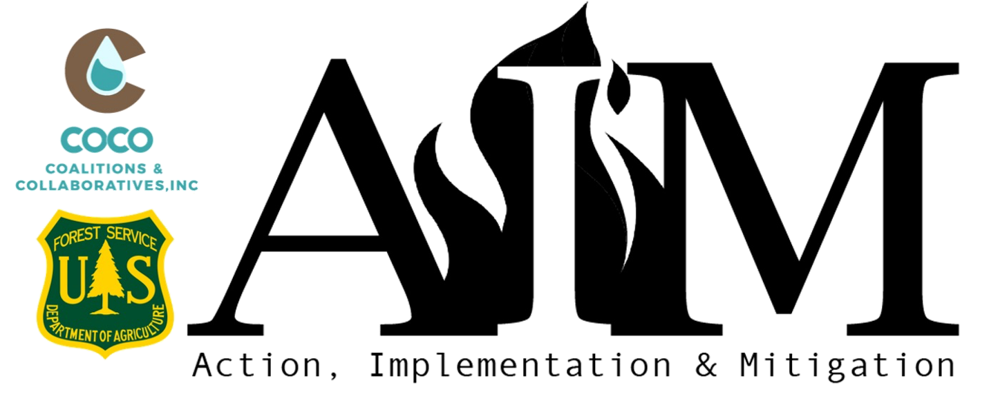
Spring 2023 AIM Concept Paper
Project Title
Organization Name
Organization Phone Number
Physical Address Street |  | City
State | Select State. | ZIP
Project Manager Name
Project Manager Title
Project Manager Phone Number
Website URL
Fiscal Agent (If Applicable)
Organization UEID#

Organization Type | Please select an organization type.
Proposal Focus Area | Check all that apply.

- WILDFIRE RISK REDUCTION ACTIVITIES (1,250 characters)
Please describe your organization's specific wildfire mitigation accomplishments in the last two years.
Click or tap here to enter text.

- PROJECT DESCRIPTION (1,500 characters)

Click or tap here to enter text.

- Project Timeline
Outline the proposed timeline for each activity/component of the project, including major milestones and the anticipated outcomes that will define project completion. If you are working through a multi-year project, clearly define the portion which AIM funding will support.

Example Activity Timeline:
May –mobilize contractors and equipment
June –work begins, goal 2 miles/approx. 18 acres
July – work goal 2 miles/approx. 18 acres
August – work could slow due to fire conditions, goal 1 mile/approx. 9 acres
September – work could slow due to fire conditions, goal 1 mile/approx. 9 acres
October – work goal 14.2 acres
November - shaded fuel break completed
Dec-March - write and share project success stories

Click or tap here to enter text.

- STRATEGIC VALUE OF PROJECT (1,500 characters)
How will this project increase mitigation activities, or create broader collaborative landscape risk reduction efforts in a strategic way over time? Based on the category(s) for which you are seeking AIM funding, explain how your project contributes to the greater wildfire management strategy in your community.

Click or tap here to enter text.

- MAINTENANCE AND SUSTAINABILITY (1,000 characters)
Clearly demonstrate how this proposal will remain effective after the closing of your AIM award by outlining the commitments from partners and/or residents, and potential future funding sources (anticipated or committed).

Click or tap here to enter text.

- MATCH AND BUDGET
Please fill out the attached Budget Sheet and return with your Concept Paper:
AIM Budget Table - Online Application

Send your completed Concept Paper and Budget sheet to: AIM@co-co.org by 5:00 PM MST, Tuesday, February 24, 2023.

