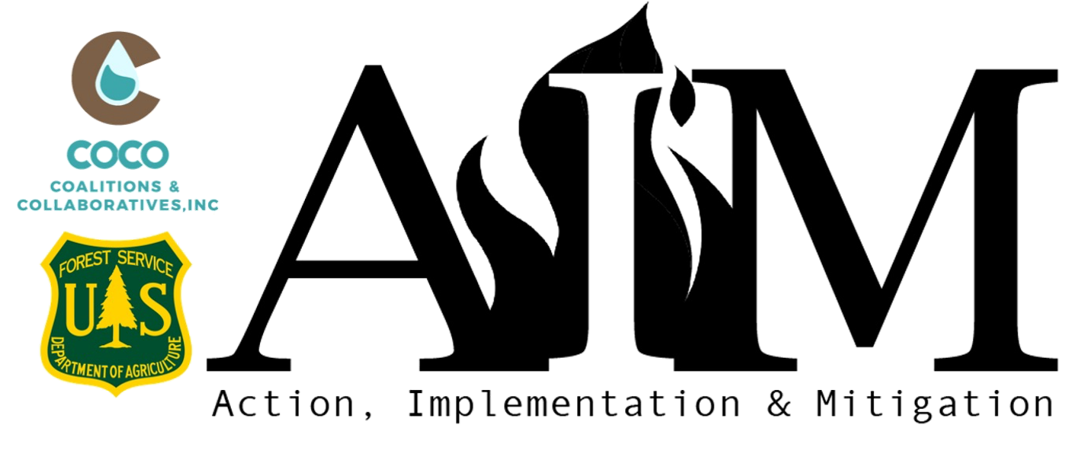
Spring 2024 AIM Concept Paper
Project Title
Organization Name
Organization Phone Number
Physical Address Street |  | City
State | Select State | ZIP
Project Manager Name
Project Manager Title
Project Manager Phone Number
Website URL
Fiscal Agent (If Applicable)
Organization UEID#

Organization Type | Please select an organization type
Proposal Focus Area | Check all that apply

- WILDFIRE RISK REDUCTION ACTIVITIES (1,250 characters)
Please describe your organization's specific wildfire mitigation accomplishments in the last two years.
Click or tap here to enter text.

- PROJECT DESCRIPTION (1,500 characters)

Click or tap here to enter text.

- Project Timeline
Outline the proposed timeline for each activity/component of the project, including major milestones and the anticipated outcomes that will define project completion, grouping similar activities where appropriate. If you are working through a multi-year project, clearly define the portion which AIM funding will support.

Example Activity Timeline:
May - mobilize contractors and equipment
June - work begins, goal 2 miles/approx. 18 acres
July - work goal 2 miles/approx. 18 acres
Aug-Sept - work could slow due to fire conditions, goal 2 mile/approx. 18 acres
October - work goal 14.2 acres
November - shaded fuel break completed
Dec-March - write and share project success stories

Click or tap here to enter text.

- STRATEGIC VALUE OF PROJECT (1,500 characters)
How will this project increase mitigation activities within your community, or create broader collaborative landscape risk reduction efforts in a strategic way over time? Please explain how your project contributes to the greater wildfire management strategy in your community.

Click or tap here to enter text.

- MAINTENANCE AND SUSTAINABILITY (1,000 characters)
Clearly demonstrate how this proposal will remain effective after the closing of your AIM award by outlining the commitments from partners and/or residents, and potential future funding sources (anticipated or committed).

Click or tap here to enter text.

- BUDGET TABLE AND NARRATIVE
Please fill out the attached Budget Sheet and return with your Concept Paper:
AIM Budget Table - Online Application

Send your completed Concept Paper and Budget sheet to: AIM@co-co.org by 5:00 PM MT, Friday, February 23, 2024.

